Data Set Background:

Real Estate Across the United States (REXUS) Inventory (Building)

Real Estate Across the United States (REXUS) is the primary tool used by PBS to track and manage the government’s real property assets and to store inventory data, building data, customer data, and lease information. STAR manages aspects of real property space management, including identification of all building space and daily management of 22,000 assignments for all property to its client Federal agencies. This data set contains PBS building inventory that consists of both owned and leased buildings with active and excess status.

You can visualize data with many different filters and parameters. In below I have added few example screen shots.

Image -1

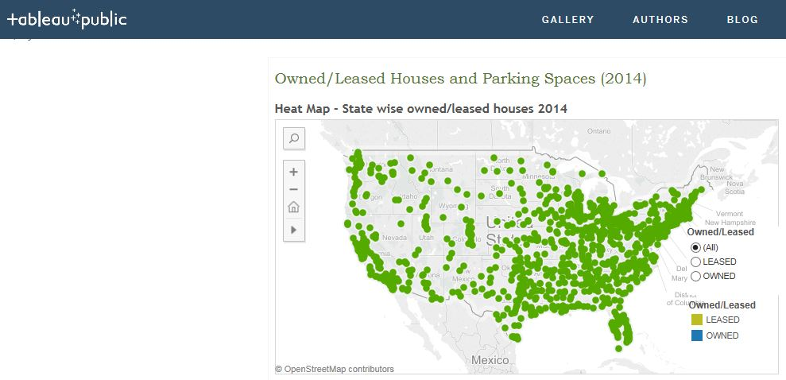

Image -2

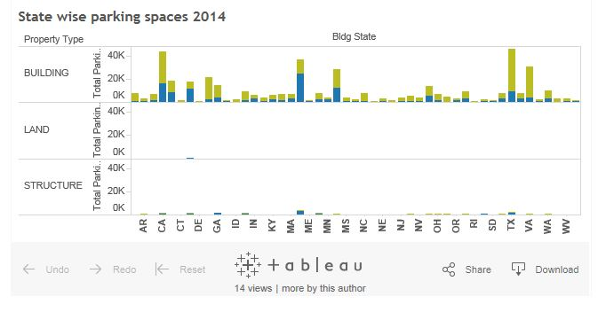

Perform below given task

1. Prepare Heat Map for state wise Owned/leased houses of year 2014. Keep filter option for ender user to selected Owned or leased. Please refer image-1.
2. Prepare column chart to compare state wise parking area for each property type. Please refer image-2.
3. Prepare dashboard to display both reports together. Keep filter option based on owned/lease column for end user. Also make send report to be used as filter options.